**zSalesforce Project Report: To Supply Leftover Food to Poor by SmartInternz**

**Overview**

This report provides a comprehensive overview of the Salesforce customizations and configurations performed for the project "To Supply Leftover Food to Poor" by SmartInternz. The aim was to set up Salesforce for a Non-Governmental Organization (NGO) with specific objects, fields, relationships, flows, triggers, profiles, groups, report types, custom reports, dashboards, and sharing rules.

**Account**

* **Account Created and Activated:** The initial Salesforce account was successfully created and activated for use.

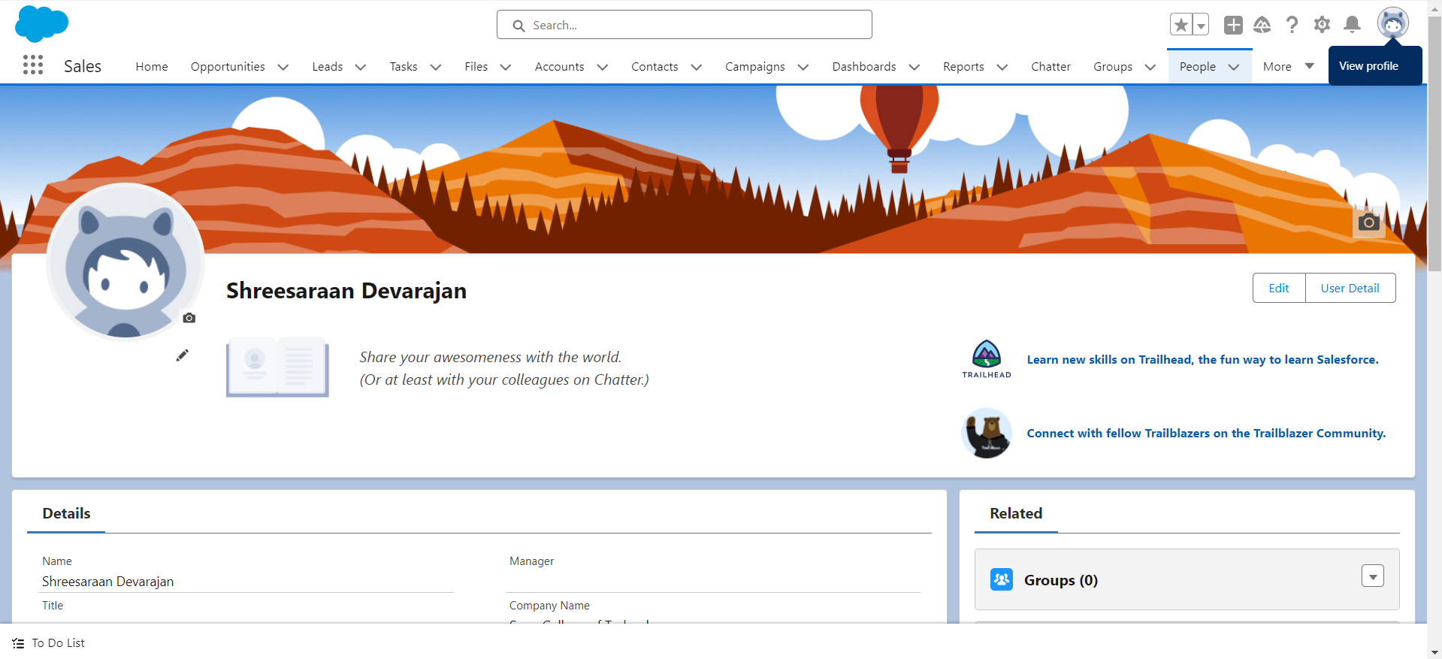

**Custom Objects**

* **Venue Object:** Custom object created to manage and store information about different venues.

* **Drop-Off Point Object:** Custom object created to manage and store information about various drop-off points.

* **Task Object:** Custom object created to manage and store information about tasks.

* **Volunteer Object:** Custom object created to manage and store information about volunteers.

* **Execution Details Object:** Custom object created to manage and store execution details.

**Custom Tabs**

* Custom tabs were created to facilitate easy access to the custom objects.

**Lightning App**

* A Lightning app was created to provide a user-friendly interface for managing the custom objects and data.

**Fields and Relationships**

* **Venue Object:** Custom fields and relationships were defined to capture specific details about venues.

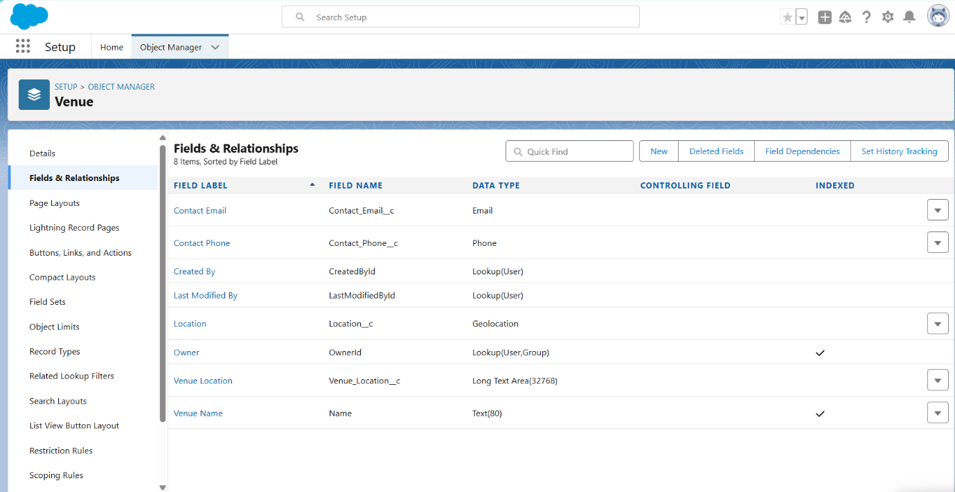

* **Drop-Off Point Object:** Custom fields and relationships were defined to capture specific details about drop-off points.

* **Task Object:** Custom fields and relationships were defined to capture specific details about tasks.

* **Volunteer Object:** Custom fields and relationships were defined to capture specific details about volunteers.

* **Execution Details Object:** Custom fields and relationships were defined to capture specific details about execution details.

**Flows**

* A flow was created to record data in the Venue Object, ensuring efficient and streamlined data entry.

**Trigger**

* A trigger was implemented to update the distance field in the Drop-Off Point Object automatically.

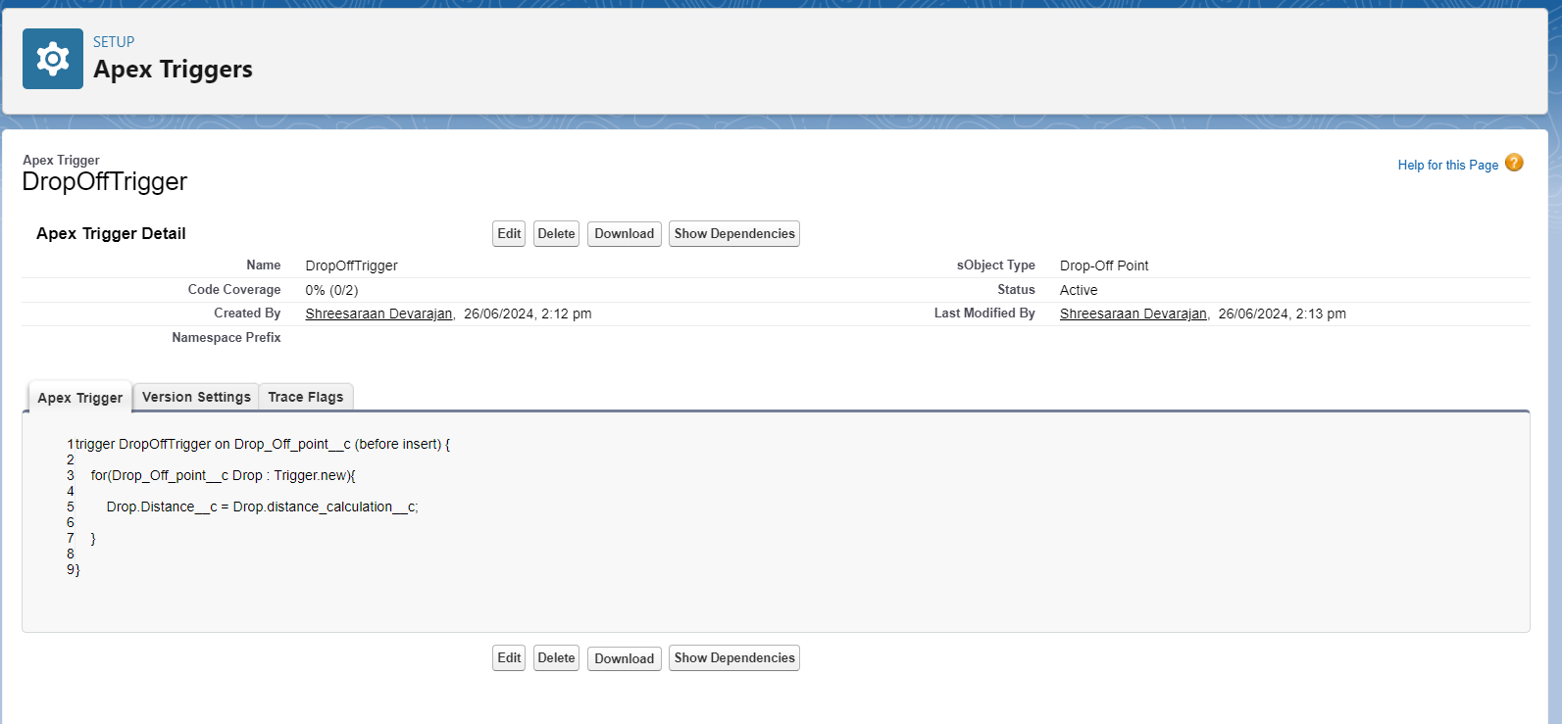

**Profiles**

* **NGO Profile:** A custom profile was created for three users to manage their access and permissions.

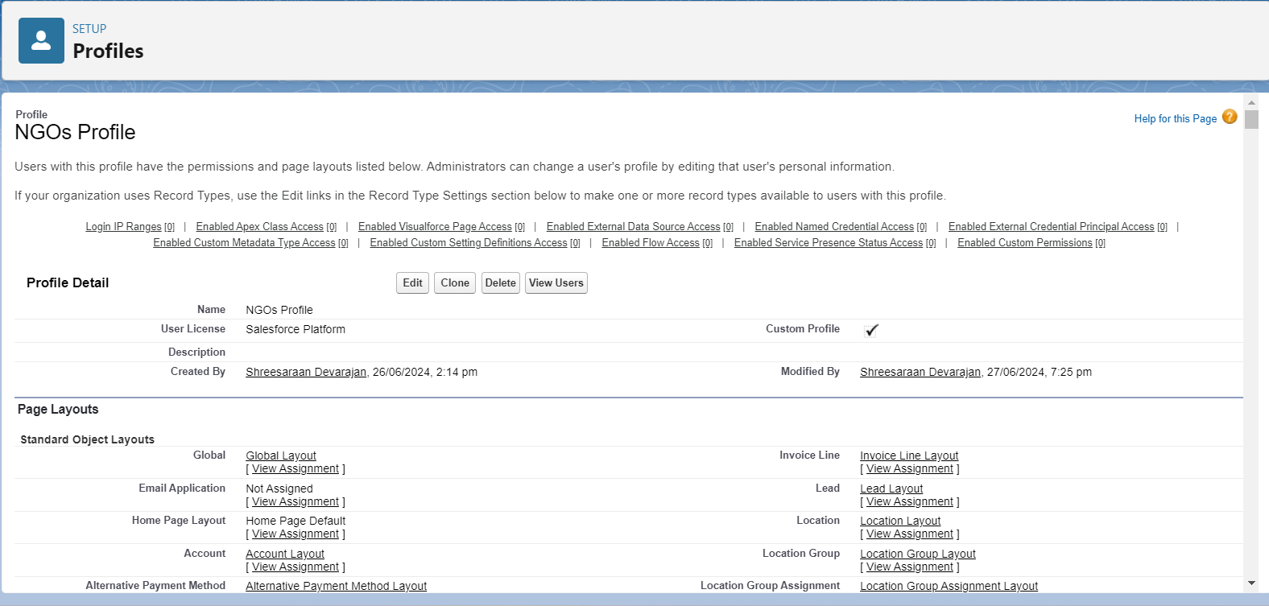

* **Users:** Three custom users were created.

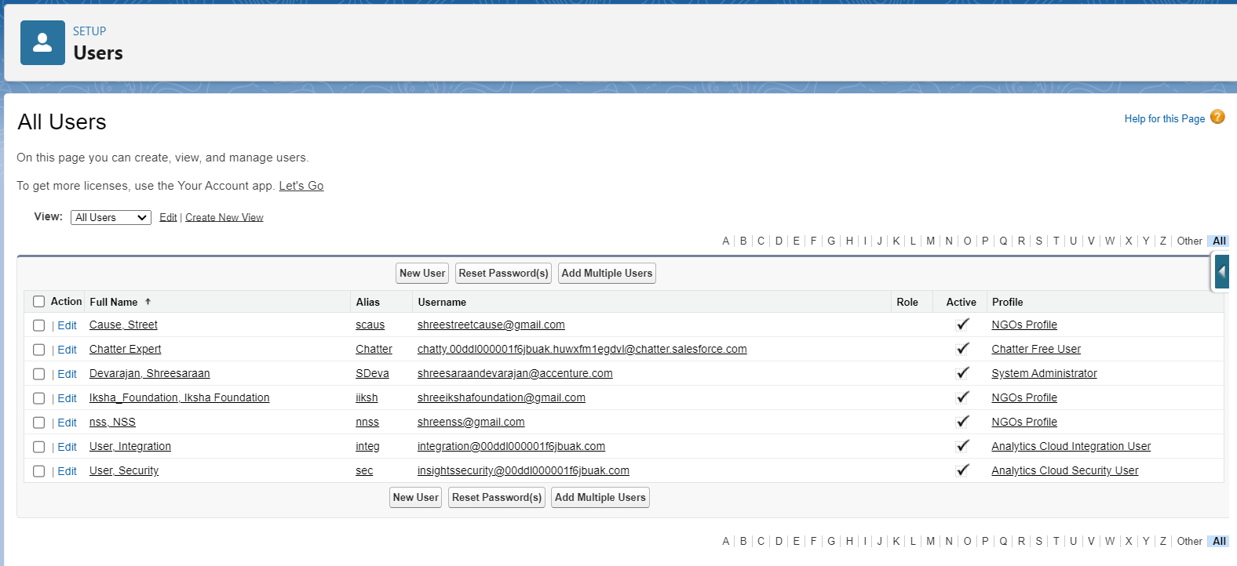

**Public Groups**

* Three public groups were created to facilitate collaboration and data sharing among users.

**Report Types**

* Custom report types were created to enable the generation of specific reports tailored to the NGO's needs.

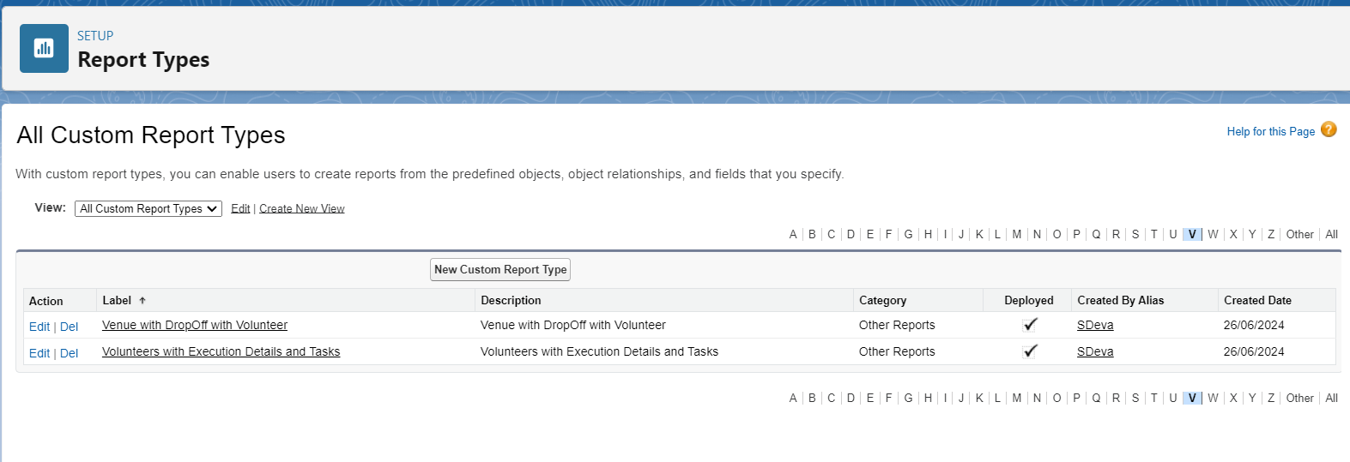

**Reports**

* Two custom reports were created to provide insights and analytics on the data.

**Dashboard**

* A custom dashboard was created to display the custom reports, providing a visual representation of key metrics and data. An image was added to enhance the dashboard's appearance.

**Sharing Rules**

* Three sharing rules were created in the Drop-Off Point Object to share data with users based on distance criteria.

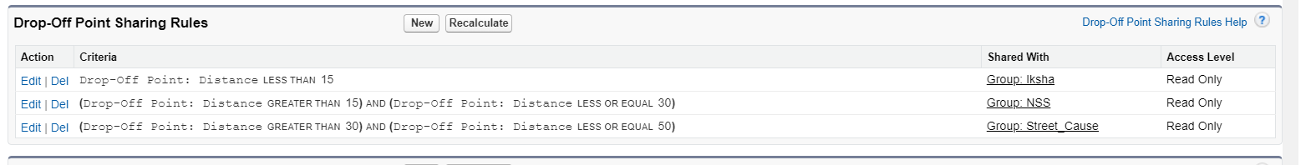

**Home Page**

* A custom home page was created, which is displayed when the app is opened, providing users with an overview and easy access to key functionalities.

**Conclusion**

The Salesforce setup for the project "To Supply Leftover Food to Poor" by SmartInternz was successfully completed. The configurations and customizations implemented will enable the NGO to efficiently manage and track their operations, ensuring a streamlined process for supplying leftover food to the poor.